Source
This dataset is collected from the Michigan Department of Education where they reported average teacher benefits along with average salary.

Explain the theory behind your model
The above model used in the Wooldridge text book (Wooldridge, pages: chapter 4, c11, page: 161). I haven’t found any dummy variable in this model so I added a dummy variable called urban. After adding the dummy variable my model looks as follows:
$$\hat{educ}= β_{0} + β_{1}motheduc+β_{2}fatheduc+ β_{3}abil+β_{4}urban+ \hat{u}$$
Here in the model,
Dependent variable
- educ: highest grade completed by 1991
Independent variables
- motheduc: highest grade, mother
- fatheduc: highest grade, father
- abil: abil. measure, not standardized
- urban: =1 if in urban area, 1991
In this model, I am going to estimate the educ (highest grade completed by 1991), which is dependent on motheduc, fatheduc, abil, urban. How much education changes, if any value changes in the independent variable. For example, if mother is higher educated, is the children education will increase or decrease?

Determine the functional form
One of the assumptions of the classical linear regression model (CLRM), Assumption 9, is that the regression model used in the analysis is “correctly” specified: If the model is not “correctly” specified, encounter the problem of model specification error or model specification bias. It can be happened for various reason. So, my regression equation looks as follows:
There are multiple ways to test the specification errors. Here, to determine the functional form, I am going to use Ramsey Reset test.
The steps involved in RESET are as follows: Assignment 16
Step 1. From the chosen model, obtain the estimated result of educ, that is yhat.
Step 2. Rerunning the regression Equation by introducing yhat_2, yhat_3, yhat_4 in some form as an additional regressors. Thus, we run,
Step 3. Let obtained R2 from both equation and calculating F value by applying the following formula:
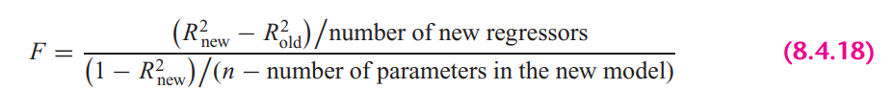
In STATA, the calculation looks as follows:

Step 5. If the computed F value is significant, at the 5 percent level, one can accept the hypothesis that the model is mis-specified.
Findings: From the results we can see that, F value is significant at 5% percent significance level, therefore, we can not reject the hypothesis that the model is misspecified.

STATA version Ramsey rest test gives the following result:
It also suggest the same result. Here we cannot reject the null hypothesis (Model has no omitted variables) at 95% confidence level. So, from all of the test, we can conclude that, the chosen model is misspecified.

Explain the OLS equation
.
In STATA, by the following command, obtained regression result.

Findings from the result:
R-squared: R-Squared is the proportion of variance in the dependent variable (educ) which can be predicted from the independent variables (motheduc, fatheduc, abil, urban). This value indicates that 42.92% of the variance in lavgsal can be predicted from the variables motheduc, fatheduc, abil, urban.
motheduc: Here the coefficient is .1854 means that If mother education increase by 1 grade, will expect an increase of child education (educ) by .1854 grade, holding other variables constant. The variable is statistically significant at 5% significance level.
fatheduc: Here the coefficient is .107 means that If father education increase by 1 grade, will expect an increase of child education (educ) by .107 grade, holding other variables constant. The variable is statistically significant at 5% significance level.
abil: Here the coefficient is .5005 means that If ability increase by 1 point, will expect an increase of education (educ) by .5005 grade, holding other variables constant. The variable is statistically significant at 5% significance level.
urban: Here the coefficient is .2794 means for urban students predicted education is higher by .2794 grade than the non-urban students, holding other variables constant. The variable is statistically significant at 5% significance level.
const: When all the explanatory variables value is 0, in average educ is 8.31 grade.

Heteroskedasticity test

A sequence of random variables is homoscedastic if all its random variables have the same finite variance. This is also known as homogeneity of variance. The complementary notion is called heteroscedasticity, where:

$$Var\left(u_{i}\right)≠ σ^{2}$$
Therefore, having an equal variance means that the disturbances are homoscedastic. However, it is quite common in regression analysis for this assumption to be violated. In this assignment, I am going to test heteroskedasticity by applying different methods.
- Graphical Method
Graphical method is also known as the informal way, is by inspection of different graphs. Heteroskedasticity can be detected by the scatter plot. However, this cannot be done in the multiple regression case. In this case useful information about the possible presence of heteroskedasticity can be given by plotting residuals against the dependent variable or single explanatory variable.
To plot the heteroskedasticity I have followed the following steps:
- Run the regression equation and obtained the residuals of this regression equation

- Plotting residuals against the regression fitted values by STATA built in command

Here, if we look at the residual plot against individual explanatory variable, it looks as follows
Findings
If we look at the residual plot against fitted values, we can see variance is not constant as fitted value increases. In the same way, we can see the relationship between residuals and explanatory variable is not constant as the value of individual variable either increases or decreases or the variance is not constant across observations.

- Park test

- Run the regression of Equation and obtain the residuals (µ_{i}) of this regression equation.

- Run the following auxiliary regression:
Since, log of 0, can make a variable undefined. Therefore, I didn’t transform urban variable to log(urban).
$$\ln\left(\hat{u_{i}^{2}}\right)= α_{0} +α_{1 }\ln\left(motheduc\right)+α_{2}\ln\left(fatheduc\right)+ α_{3}\ln{(abil)}+α_{4} urban+ e_{i}$$

- To interpret the auxiliary regression result, we need to formulate the null and the alternative hypotheses. The null hypothesis of homoskedasticity is:
$$H_{0}: { α}_{1}= α_{2}=…= α_{p}=0; Homoskekdasticity$$
$$H_{a}: any { α}_{p} ≠ 0; Heteroskedasticity$$
From the auxiliary regression, we can see explanatory variables, lmotheduc and lfatheduc, p-value is greater than the alpha (level of significance) value, which makes the variables statistically insignificant. In this case we do not reject the null hypothesis or ${ α}_{1}= α_{2}=0$. Here, the alternative is that at least one of the a’s is different from zero, in this case variables labil and urban coefficients are different from zero $α_{3}≠ α_{4}≠ 0$. So, from the hypothesis assumption, we can reject the null hypothesis. Therefore, we can conclude that park test says, there are heteroskedasticity presence in the model.
- Computing the LM statistics (LM = nR²), where n is the number of observations used in order to estimate the auxiliary regression in Step 2, and R² is the coefficient of determination of this regression. The LM-statistic is distributed under a chi-square distribution with degrees of freedom equal to the number of slope coefficients included in the auxiliary regression (or k − 1), which in my case is 4 and significance level is 5%.

Findings from the Park Test
As we have seen at step 3 that we can reject the null hypothesis and also from the LM test we can see that, NR2 is greater than the critical chi2 value. So, in this case we also can reject the null hypothesis of constant variance (presence of heteroskedasticity).

- Glesjer test

The Glesjer test can be performed in STATA as follows:
- First, the regression equation model is estimated with OLS, using the command and predict (gen) command is used to obtain the residuals (u_{i})
- Run the following auxiliary regression:
$$\left|\hat{u_{i}}\right|= α_{0} +α_{1 }motheduc+α_{2} fatheduc+ α_{3}abil+α_{4} urban+ e_{i}$$
- To interpret the auxiliary regression result, formulate the null and the alternative hypotheses. The null hypothesis of homoskedasticity is:
$$H_{0}: { α}_{1}= α_{2}=…= α_{p}=0; Homoskekdasticity$$
$$H_{a}: any { α}_{p} ≠ 0; Heteroskedasticity$$
Here, the alternative is that at least one of the a’s is different from zero, in which case at least one of the variable’s affects the variance of the residuals, which will be different for different i. From the auxiliary regression, we can see explanatory variables, lmotheduc and lfatheduc, p-value is greater than the alpha (level of significance) value, which makes the variables statistically insignificant. In this case we do not reject the null hypothesis or ${ α}_{1}= α_{2}=0$. Here, the alternative is that at least one of the a’s is different from zero, in this case variables labil and urban coefficients are different from zero $α_{3}≠ α_{4}≠ 0$. So, from the hypothesis assumption, we can reject the null hypothesis. Therefore, we can conclude that Glesjer test says, there are heteroskedasticity presence in the model.
- Computing the LM statistics (LM = nR²), where n is the number of observations used in order to estimate the auxiliary regression in Step 2, and R² is the coefficient of determination of this regression. The LM-statistic follows the χ² (chi-square) distribution with p − 1 degrees of freedom.
Findings from the Glesjer Test
As we have seen at step 3 that we can reject the null hypothesis and also from the LM test we can see that, NR2 is greater than the critical chi2 value. So, in this case we also can reject the null hypothesis of constant variance, which indicates the evidence of heteroskedasticity.

- Gold field Quandt test

To detect the heteroskedasticity by gold field quandt test, involving the following steps:
- Sort the data according to the variable abil.
- Breaking the sample into two different sub-samples. To choose the sub samples, the following formula can be applied:
$$c=Total observation/5$$
$$Sub sample size =(Total observation-c)/2$$

So, from the first and last, sample size is 616 by excluding the middle observations.

- Now run OLS for both sub-samples in order to obtain the Mean square of residual (RSS/df), using the following commands:

- Calculating F-statistics for Gold Quandt, F-critical and P-value as follows:

Findings from the Gold Field Quandt Test
Final conclusion can be made from the F-statistics and F-critical values. Since F-statistics is greater than the F-critical value, therefore it indicates the evidence heteroskedasticity.

- Breusch-Pagan Godfrey test

- Estimate Eq. by OLS and obtain the residuals
- Obtaining variance $σ^{2}$ of the regression by applying the following calculations in STATA
- Constructing variables P_{i} defined as
- Regress P_{i} thus constructed on the Z’s as
$$p_{i}= α_{0} +α_{1 }motheduc+α_{2} fatheduc+ α_{3}abil+α_{4} urban+ e_{i}$$

- Obtaining the ESS from the above regression result and defining theta as follows:

- THETA follows the chi-square distribution with (K − 1) degrees of freedom, so the chi² critical values with 4 degrees of freedom and 5% significance level as follows:

Findings from the Breusch-Pagan Godfrey Test
If in a model the computed THETA (= χ2) exceeds the critical χ2 value at the chosen level of significance, one can reject the hypothesis of homoscedasticity. Here from the result, we can see that THETA > chi², therefore it indicates the presence of heteroskedasticity in the model.

- White’s general heteroskedasticity test

- The regression equation model is estimated with OLS, using the command to obtain the residuals (u_{i})

- Run the following auxiliary regression
Here, I have omitted urban², since urban is a dummy variable, adding square term of a dummy variable can create multicollinearity.
$$u_{i}^{2}= α_{0} +α_{1 }motheduc+α_{2} fatheduc+ α_{3}abil+α_{4} urban+ α_{5 }{motheduc}^{2}+α_{6} {fatheduc}^{2}+ α_{7}{abil}^{2}+ e_{i}$$

- To interpret the auxiliary regression result, formulate the null and the alternative hypotheses. The null hypothesis of homoskedasticity is:
$$H_{0}: { α}_{1}= α_{2}=…= α_{p}=0; Homoskekdasticity$$
$$H_{a}: any { α}_{p} ≠ 0; Heteroskedasticity$$
Here, the alternative is that at least one of the a’s is different from zero, in which case at least one of the variable’s affects the variance of the residuals, which will be different for different i. From the auxiliary regression, we can see some of the explanatory variable’s p-value is greater than the alpha (level of significance) value, which makes the variables statistically insignificant. In this case we do not reject the null hypothesis or ${ α}_{1}= α_{2}{=α}_{3}= α_{6}=0$. But the alternative is that at least one of the a’s is different from zero, in this case variables labil and urban coefficients are different from zero $α_{4}≠ α_{7}≠ 0$. So, from the hypothesis assumption, we can reject the null hypothesis. Therefore, we can conclude that General white test says, there are heteroskedasticity presence in the model.
- Computing the LM statistics (LM = nR²), where n is the number of observations used in order to estimate the auxiliary regression in Step 2, and R² is the coefficient of determination of this regression. The LM-statistic follows the χ² (chi-square) distribution with p − 1 degrees of freedom.

Findings from the white LM test
Final conclusion can be made by comparing the LM statistics and chi square critical value. Reject the null and conclude that there is significant evidence of heteroskedasticity when LM-statistical is greater than the critical value (LM-stat > χ2 _{7, 0.5}).

Autocorrelation test

One of the assumptions of the CLRM states that the covariances and correlations between different disturbances are all zero.
$$Cov\left(u_{i}, u_{j}\right)=0 for all i=j$$
This assumption states that the error terms $u_{i}$ and $u_{j}$ are independently distributed, termed serial independence. If this assumption is no longer true then the disturbances are not pairwise independent, but are pairwise autocorrelated.
In this situation:
$$Cov\left(u_{i}, u_{j}\right)≠0 for all i≠j$$
which means that an error occurring at period i may be correlated with one at period j.
In this assignment I am going to test autocorrelation by different approach.

- Graphical method to detect Autocorrelation

First the regression equation model is estimated with OLS, using the following command is used to obtain the residuals (u_{i})
Because our dataset includes cross-sectional data, we need to generate time variable to plot the residuals against time.
The following command is used to create the $u_{t-1}$ lagged series of residuals. Here lag1_uhat is for the lag operator of first order.

Findings: Here, it’s hard to find any relationship by looking the scatter plot of $u_{t}$ against $u_{t-1}$, It seems like they have zero autocorrelation or have very weak positive relationship.

- Runs test

A run is defined to be a succession of one or more identical symbols which are followed and proceeded be a different or no symbol at all.
In the run test the hypothesizes are,
$$H_{0}: no autocorrelation$$
$$H_{0}: autocorrelation$$
Here, by run test we find out how many times a positive trend became negative and how many times negative trend became positive by crossing mean or median value. For the error term threshold is 0.

To see the visual how many times the error term run positively and negatively across the time.

Findings: Here, we can see p-value is less than 0.05 and we reject null hypothesis. So, run test says that the error terms are autocorrelated.

- Durbin Watson test

In STATA, the following two steps required for Durbin Watson test:

- Estimate the model by using OLS

- Estimate DW test value by the following command

A rule of thumb for d-Watson test:
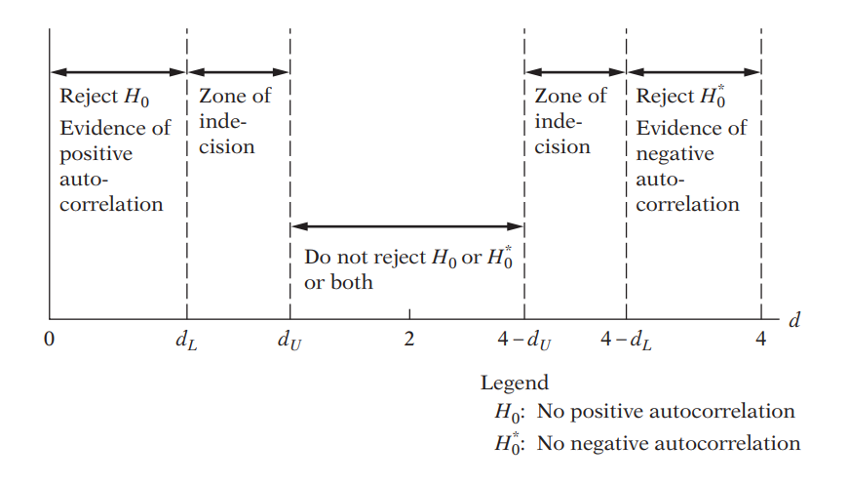
Here,
$$H_{0}: ρ=0 , errors are not correlated$$
$$H_{a}: ρ≠0 , errors are correlated$$
Since the Durbin-Watson d statistic is a function of $ρ$, the range of the test statistic is also dependent on the range of p. When,
- $ρ=0$ then d = 2
- $ρ=1$then d = 0
- $ρ=-1$then d = 4
Findings: In my case, d-statistics is 1,84, which is close to 2. Therefore, according to Durbin Watson test, most likely this is the area of zone of indecision.

- Breusch-Godfrey test

In the BG test, hypothesis are as follows:
$$H_{0}:Not autocorrelated, ρ_{1}=ρ_{2}={…=ρ}_{p}=0$$
$$H_{a}: Aotocorrelated, if any ρ≠0$$
Estimating the OLS and obtaining residuals

Here I am using 2 lags of orders to see the autocorrelation residuals and with its previous 2 lags

Moving Average equation looks as follows with 2 lags order:
$$u_{t}= p_{1}ε_{t-1}+p_{2}ε_{t-2}+ε_{t}$$

In Stata, the result looks as follows:

Findings: From the result, we can see first lag is statistically significant at 5% significance level means lag 1 influenced current lag positively. On the other hand, lag 2 error is insignificant, so 2 periods earlier error has no impact on the current error term.

Findings from the LM test: Here we can see NR2 > chi2 critical value, therefore we will reject the null hypothesis and can conclude that the model has autocorrelation

Multicollinearity test

11. Looking at the value of R-squared and t value

Findings
In this regression model, R squared is not too high, 48.82%. If we look at t-statistics of the explanatory variables, we can see that all the t value is higher, where all of the variables are statistically significant at 95% confidence interval. In this case, we can say that there are no multicollinearity presents among the explanatory variables.

12. Pair-wise correlations among regressors

In STATA, by the following command we can get pair wise correlation value of the variables.

Findings
From the results, we can see that all the variables are pair wise correlated. But here none of the variables are highly pair wise correlated. Therefore, we can conclude that there isn’t enough pairwise correlation among regressors which can cause multicollinearity problem.

13. Auxiliary regression for multicollinearity

Since multicollinearity arises because one or more of the regressors are exact or approximately linear combinations of the other regressors, one way of finding out which X variable is related to other X variables is to regress each X_{i} on the remaining X variables and compute the corresponding R², which we designate as R²_{i}.
So, first auxiliary regression, where motheduc is the dependent variable
After run the OLS, obtained R2 and F distribution and F critical value by applying the following formula from the book:
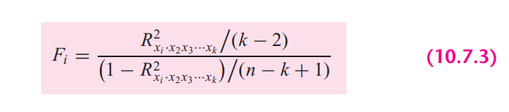
Findings: In general, if multicollinearity were presents, R square from the auxiliary regression would be very high but we can see it’s very low. And also from the F statistics, where F-dist < F-crit, means that bs is not collinear with other independent variables

So, second auxiliary regression, where fatheduc is the dependent variable
After run the OLS, obtained R2 and F distribution and F critical value by applying the following formula from the book:

Findings: In general, if multicollinearity were presents, R square from the auxiliary regression would be very high but we can see it’s very low. And also from the F statistics, where F-dist < F-crit, means that bs is not collinear with other independent variables

Third auxiliary regression, where urban is the dependent variable
After run the OLS, obtained R2 and F distribution and F critical value by applying the following formula from the book:
Findings: In general, if multicollinearity were presents, R square from the auxiliary regression would be very high but we can see it’s very low. And also from the F statistics, where F-dist < F-crit, means that bs is not collinear with other independent variables

14. Partial Correlations

In STATA, by the following command we can get partial correlation value of the variables

Findings: From the results, we can see that variables are very weekly partially correlated. But here none of the variables are highly partially correlated. Therefore, we can conclude that there isn’t enough partial correlation among regressors which can cause multicollinearity problem.

15. Condition Index

Conditional Index can be calculated as follows:

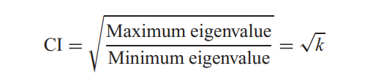
In STATA, by the following command, we can obtain the Eigenvalue and corresponding Conditional Index.

Rule of thumb: If k is between 100 and 1000 there is moderate to strong multicollinearity and if it exceeds 1000 there is severe multicollinearity. Alternatively, if the (CI = √k) is between 10 and 30, there is moderate to strong multicollinearity and if it exceeds 30 there is severe multicollinearity

Findings
From all of the observation, can see that Conditional index, Eigen value, VIF is very low for the explanatory variables. Therefore, we can conclude that, multicollinearity doesn’t exist among the regressors.

